# Configurations for Bicycles Exhibit

## Brake Exhibit

**MOVIE_FILENAME**: The name of the movie file that will be loaded and played.  
**THRESHOLD:** list of encoder readings thresholds that correspond to speed change, i.e. When encoder readings produces a value between *SPEED_TH_1* and *SPEED_TH_2*, the video playing speed will be: *SPEED_TH_1*. More steps can be added, be sure to add same step names in VID_SPEED.  
Ensure values are in ascending order.  
**VID_SPEED:** video speed factor corresponding to *THRESHOLD*.

## History Exhibit

**MOVIE_FILENAME**: The name of the movie file that will be loaded and played.  
**THRESHOLD:** above this value on any of the connected encoders – the video will play.  
This threshold applies for all connected devices (bicycles, hand cyclers etc.).  
The Threshold unit is speed.  
**CONVERSION_FACTOR:** Speed is calculated as ‘Encoder Readings’ * CONVERSION_FACTOR.  
**HOLD_BEFORE_RESTART**: Time in seconds the program waits before restarting the video if speed is below threshold for all bicycles (i.e. when no one is pedaling).

## Race Exhibit (כח חמור כך עיר) Donkey/ Foal

Most of the configurations in this exhibit are for defining the graphics location and layout, they should not be changed in normal operation.

**SPEED_FACTOR:** factors that translate from encoder to speed, we have 4 factors, 2 for Donkey exhibit and 2 for Foal exhibit,.  
[10, 10, 8.9, 18.7]: [Player 1 DONKEY, player 2 DONKEY, player_3 FOAL, player_4 FOAL]

Conversion is: **velocity = encoder_delta / SPEED_FACTOR**

## Tour Exhibit

**ENCODER_TO_SPEED_CONVERSION:** Speed is calculated as ‘Encoder Readings’ * CONVERSION_FACTOR.  
**SPEED_THRESHOLD:** above this speed value – the video will play, below: will pause.  
**DEBOUNCING_TIME:** Time in seconds after the button was pressed to ignore other button presses.  
**TIME_FOR_RETURN_TO_DEFAULT_SCENE:** Time in seconds the program waits before switching back to the beginning of the default video.

### Changing Tour Movies:

Tour movies are saved in the dictionary **SCENES**.

Demo Config:

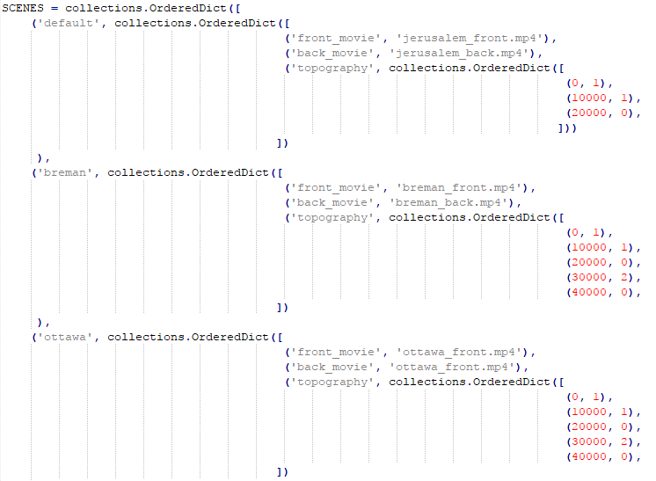

Every scene has a scene name (ie. ‘ottawa’, ‘default’), the front and back movies for this scene and a list of topographies that define the times that we have up hill/ down hill in the movie (this controls the fan and electrical break).

In the topography, the values are:

'DOWN_HILL': 0,

'UP_HILL': 1,

'MISHOR': 2

In the above example:

* You can see that the ‘default’ scene has the Jerusalem movies.
* Ottawa scene has the movie ‘ottawa_front.mp4’ as the ‘front_movie’
* In Breman scene, the first 10000[ms] have the topography 1 (up_hill), the second 10000[ms] also have 1 (up_hill), the next 10000[ms] have topography 0 (down_hill) etc.

**When changing countries:**

1. It is important to ensure that the ‘default’ scene directs to the current counties movies (every few seconds without pedaling, the exhibit will go back to the default scene)
2. If the movie files sit next to the config file (in tour_exhibit directory) it is enough to write the movie file name in front_movie and back_movie variables. If it is in another directory, the full path is needed.